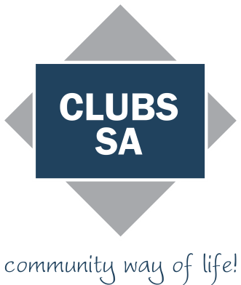

Job description template for hiring new employees
You can use this template to help you prepare a job description for a job you want to fill. A job describes the duties and responsibilities of a job. A job description help you clarify what you need from the role and can be used as the basis to develop your job advertisement.

Suggested steps for developing a job description
For information about minimum employment rights and entitlements you can also call RHYS BRAYBROOK, WORKPLACE RELATIONS MANAGER at CLUBS SA on 8290 2280 or 0448273355 or visit our website at: www.clubssa.com.au
Step 1: Define the job
The first step is to getting a clear understanding the job you want to fill and the tasks you need completed. A good place to start is to talk to the supervisor or person who the employee will be reporting to, and other employees who are working in the area.

You should consider:
- what tasks you need the new person to undertake
- what skills and abilities are needed to perform the role
- whether they need any particular qualifications or experience required
- what responsibilities the new person will have.

Step 2: Decide on the type of employment
You will need to decide on the type of employment the job needs. That is, whether the position is full-time, part-time, fixed-term or casual. This is important because it will determine the employee’s pay and conditions.

You should determine:
- the number of hours needed to do the job
- how long the job will be for (indefinitely or for a specified time or task)
- whether the employee is a junior, apprentice or trainee.

Step 3: Create the job description
Once you have defined the role, you can use the information to develop a job description. The below has been colour coded to help you to complete it. Simply replace the <red> writing with what applies to your situation. Explanations and/or examples are shown in blue italics and should be deleted once
you have finished the form.
JOB DESCRIPTION

JOB TITLE: <Role name> e.g. Receptionist, Sales assistant

JOB TYPE: <Type of employment> e.g. Full-time; Part-time; Casual

LOCATION: <The physical address that the employee will work at. If the job requires travel, state the primary location> e.g. Smithton office

SUPERVISOR/MANAGER: <Who the employee will report to> e.g. Office Manager; Shift Supervisor

MAIN DUTIES/RESPONSIBILITIES:
<Outline the duties and responsibilities of the position>

- Coordinate and carry out all office administration including reception, mail, couriers, greeting clients and filing
- Maintain a clean and safe workspace, and abide by workplace health and safety policies and procedures
- Other tasks as directed

SKILLS & EXPERIENCE

Qualifications: <What qualifications, licences or education level does the employee need?>

- Diploma or Certificate IV in Business Admin or relevant experience
- First aid certificate
Experience: <What type and how much experience is needed?>

- 3 years previous experience in an similar role/industry
Skills: <List skills needed for the job, including any technical or interpersonal skills>

- Intermediate to advanced Microsoft Office skills (Word, Excel, PowerPoint and Outlook)
- Excellent verbal and written communication
- Organised and able to meet deadlines

PERFORMANCE GOALS: <The level of performance you expect from the employee >

- Complete administration tasks on time
- Deal with clients, suppliers and other employees professionally at all times
- Ensure office is clean and presentable at all times

